   | Draft  Report | P1225 Events 2012  Visitor Research and Economic Impact Assessments
For Liverpool City Council

Sea Odyssey 20th-22nd April 2012

Prepared for
Liverpool City Council


15th May 2012

www.vector-research.net

 | REPORT |  | contents
 |  |  | Executive summary |  |  |  | 3
 | 1 |  | Background and Introduction |  |  |  | 5
 |  |  | 1.1 Introduction |  |  |  | 5
 |  |  | 1.2 Research requirements |  |  |  | 5
 |  |  | 1.3 Research approach |  |  |  | 6
 | 2 |  | Findings (1) profile & origin of visitors |  |  |  | 7
 |  |  | 2.1 Profile data of respondents |  |  |  | 7
 |  |  | 2.2 Group composition |  |  |  | 10
 | 3 |  | Findings (2) residents, staying visitors & day visitors |  |  |  | 12
 |  |  | 3.1 Type of visitor |  |  |  | 12
 |  |  | 3.2 Accommodation details |  |  |  | 12
 | 4 |  | Findings (3) visitor behaviour |  |  |  | 14
 |  |  | 4.1 Method of travel |  |  |  | 14
 |  |  | 4.2 Main reason or visiting Liverpool |  |  |  | 14
 |  |  | 4.3 Reasons for visiting event |  |  |  | 16
 | 5 |  | Findings (4) marketing |  |  |  | 18
 |  |  | 5.1 Effectiveness of marketing activity |  |  |  | 18
 | 6 |  | Findings (5) visitor satisfaction |  |  |  | 19
 |  |  | 6.1 Repeat visitors |  |  |  | 19
 |  |  | 6.2 Satisfaction with event |  |  |  | 19
 |  |  | 6.3 Satisfaction with Liverpool |  |  |  | 22
 | 7 |  | Economic impact |  |  |  | 22
 |  |  | 7.1 Average visitor spend |  |  |  | 22
 |  |  | 7.2 Spend of visitors in Liverpool – Music on the Waterfront main reason for visit |  |  |  | 23
 |  |  | 7.3 Summary of Economic Impact |  |  |  | 23
 |  |  | 7.4 Gross visitor spend |  |  |  | 24
 |  |  | 7.5 Step 2: multiplied expenditure |  |  |  | 25
 |  |  | 7.6 Step 3: additional expenditure related to the event |  |  |  | 27
 |  |  | 7.7 Total economic impact |  |  |  | 28
 | 8 |  | North Liverpool questions |  |  |  | 30
 | Appendix 1 |  | Questionnaire |  |  |  | 32
 | Report Prepared by |  |  | Report Checked by |  | Date | Version
 | C Bourne & C King |  |  | Paul Baker |  | 15.05.12 | 1
 |  |  |  | Vector Research Limited  14 Hylton Street, Birmingham, B18 6HN |  | Tel: (0121) 507 9550; Fax: (0121) 554 5615;  E-mail: info@vector-research.net
 |  |  |  |  | executive summary
 |  |  |  |  | The Sea Odyssey event took place between 20th April and 22nd April 2012, with an estimated attendance of 800,000. This report is based on data collected from 384 face-to-face interviews with attendees at the event, with this representing estimates of spend for up to 1,267 individuals.
profile & visitor origin |  |  |  |  | - There was significant representation of all age groups ranging from  - a quarter (24%) aged 65 or over  - 16 per cent aged 10 and under  - There was an even gender split – with 52 per cent females and 48 per cent males recorded.  - There was something of a bias in terms of white-collar ABC1 households who accounted for 63 per cent of attendees.  - Two thirds (67%) of the attendees originated from Merseyside (43% were from Liverpool), with a further 18% from neighbouring counties of the North West.
residents, day and staying visitors |  |  |  |  | - Over four in ten (43%) of respondents were residents of the city.  - Around one in eight (13%) were on a staying visit, or making a visit to Sea Odyssey as part of a holiday.
visitor behaviour |  |  |  |  | - The majority arrived by public transport with 45 per cent using rail, 11 per cent bus and 5 per cent by ferry.  - Over 8 in 10 said that the event was a reason for being in Liverpool on the day they were interviewed, and two-thirds (67.7%) stated it was their sole reason.  - The decision to visit the event was most likely to be made in the 7 days before the event (over three-quarters of all respondents made the decision within the last 7 days - 34% on the day itself).
marketing |  |  |  |  | - Unlike most previous event evaluations it was TV coverage that had greatest penetration in terms of media influences – seen by half (49%) of visitors (note that a significant proportion of the sample were interviewed on Friday in advance of key TV coverage). Newspaper coverage was seen by 26.6 per cent of visitors –and these two sources also had the biggest influence on people’s decision to visit the event accounting for over 4 in 10 visitors.
visitor satisfaction |  |  |  |  | - Customer satisfaction ratings were generally high. Overall enjoyment and event quality received highly positive scores, with over nine in ten rating it very/fairly good. The most positive response was for overall impression of Liverpool – rated positively by 98 per cent of respondents.  - Lower satisfaction was evident for event signposting (the only criterion receiving negative responses from more than 10 per cent)along with event parking and other facilities.  - An impressive 94% of those attending the event would be very/quite likely to recommend the event to friends and family.
economic impact |  |  |  |  | - The average spend by all visitors to the Festival was approximately £40.74 per person per night. Visitors staying overnight in the city spent on average £34.55 per person per night on accommodation  - Gross visitor spend is calculated as £31,028,167 of which £14,424,187 was spent in Liverpool itself and £205,277 elsewhere in the North West.  - £9,956,491 of the visitor spend and £5,106,219 generated in local supply businesses is estimated to be additional or abstracted spend generated for Liverpool that would not have occurred had the event not been held.  - The net direct and indirect impact of the Sea Odyssey Festival to the Liverpool economy was £32,258,322. However, this is based on visitor spending only and would have been higher if the spending by businesses involved in the event had been included in the study.

section 1 |  | background and introduction
1.1 introduction
Following the success of Liverpool’s programme of events to celebrate its year as European Capital of Culture in 2008, an events programme has been developed to run since then. In order to monitor the impact of these events and to ensure that they can continue to be improved and developed in future years, Vector Research was commissioned to conduct a series of visitor and economic impact studies at four key events during 2012.

Event research was brought together by Liverpool City Council in both 2007 and 2008 to more fully understand the economic impacts of the City’s 800th birthday year and 2008 Capital of Culture events programme. The 2012 programme of research builds on work carried out in previous years, allowing comparisons to be drawn between events.

The Sea Odyssey took place between 31st July and 2nd August 2009. The event generated an estimated attendance of 800,000.

1.2 research requirements
The research aims were:
- To identify and quantify the visitor element of economic impact of the 2012 events programme in Liverpool, Merseyside and North West England, including the number of jobs created and supported;
- To develop a profile of the audiences for each of the events included in the research, and;
- To obtain consumer perceptions of the events and suggestions for future improvements, from both local residents and visitors.

More specifically the research was designed to use fieldwork and multiplier analysis to gather:
- Audience Profile;
- Lifestyle characteristics;
- Motivations, key drivers and triggers for attendance including the role of the city in deciding to visit;
- Influence of marketing in the decision to attend;
- Length of stay in Liverpool and NW England;
- Modes of transport used to travel to, and within the City;
- Quality of experience including satisfaction with and image of the events and Liverpool, and;
- Visitor expenditure (direct, indirect and induced).

1.3 the research approach
The Vector Team conducted 384 face-to-face interviews with visitors at the Sea Odyssey.

The fieldwork was conducted at key sites on the planned routes over the three days - using a method of random sampling and was spread by time of day n order to ensure a representative coverage. Interviews were thus conducted on Friday (20th) Saturday (21st) and Sunday (22nd) as follows:

table 1 | Sampling locations
 | Friday | Saturday | Sunday
Albert Dock | 163 | 201 | 20
Albert Dock | 63 | 5 | 10
Kings Dock | 56 | 92 | 2
Pier Head | 0 | 46 | 8
St George’s Hall | 0 | 26 | 0
Everton Brow | 44 | 0 | 0
Stanley Park | 0 | 32 | 0
It should be noted then that the survey sample should not be considered representative of visitors to Liverpool in general, because event attendees were specifically targeted in order to ensure that evaluative feedback data on the events was collected.

Surveys of this nature rely on inferring characteristics of the total attendance from a small sample of visitors. Only a survey which included a very high proportion of visitors at the event could hope to achieve total accuracy in its findings.

The table below describes the confidence intervals for values in this report, based on the survey sample (384 people), taken from the total population of 800,000 (the estimated attendance), at a confidence level of 95%.

Values attributed to the respondents in this survey will fall within this range in 95% of cases.

table 1 | Confidence intervals
% Response returned | Confidence interval (+/-)
95 or 5 | 2.2%
90 or 10 | 3.0%
80 or 20 | 4.0%
70 or 30 | 4.6%
60 or 40 | 4.9%
55 or 45 | 5.0%
50 | 5.0%
 | Appendix 1 shows the questionnaire used.

section 2 | findings (1) profile & origin of visitors
2.1 profile data of respondents
2.1.1 age profile | Figure 1 below shows the age profile of respondents. With all age groups well represented there was clearly a good spread of attendance from all life-stages – but with slightly lower representation amongst the younger age groups (25-34 and in particular the 16-24 age group):
figure 1 | age profile
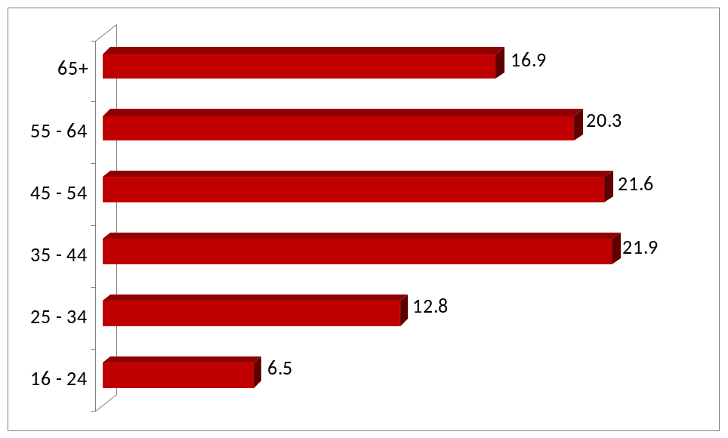
Percentages, base=379
2.1.2 gender profile |  | There was an even gender representation of respondents with 50.4 per cent female and 49.6 per cent male – and the data on all party members (see Figure 7) also shows a fairly even split (52.4% female).
2.1.3 disability |  | A significant minority of those interviewed (8.9%) considered themselves to have a longstanding illness, disability or infirmity.  The majority of this group (7.4% of the total sample) felt there were barriers which prevented them from participating fully with the event.

2.1.4 employment status |  | Figure 2 shows that over four in ten (44.2%) were working full-time and a further 11.3 per cent part-time. Over a quarter (25.9%) were retired.
figure 2 |  | employment status
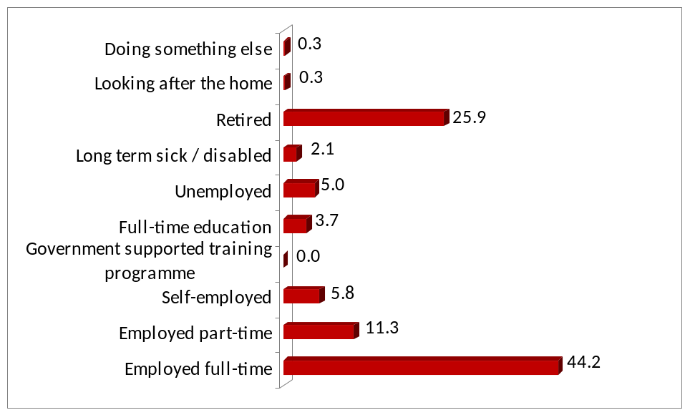
Percentages, base=381
 | Figure 3a below shows that individuals from AB (professional/managerial) households, C1s (admin/clerical) and C2s (skilled manual) were over-represented in this audience compared with the NW TV region profile> Indeed the audience comprised 63.2% visitors from ABC1 (white collar) households (which compares to regional representation of 43 per cent). Conversely the unskilled/not working DEs were under-represented, with only 15.8 per cent compared to 39.0 per cent for the region.
figure 3a | social grade (All visitors)
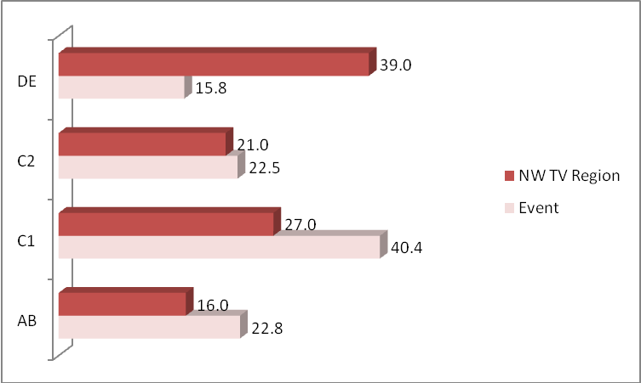
Percentages, base=326
 | The over-representation of ABs, C1s and C2s and under-representation of DEs also applies amongst Liverpool residents, as shown in figure 3b overleaf.

figure 3b | social grade (Liverpool residents)
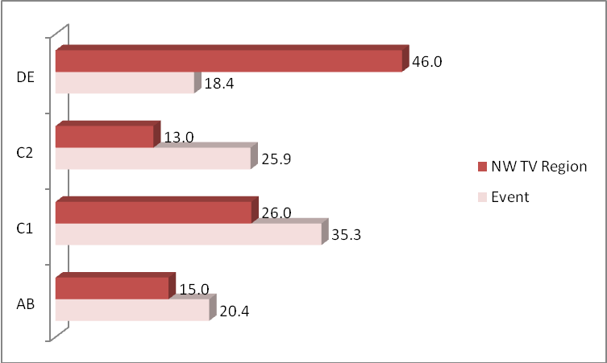
Percentages, base=161
2.1.6 location of residence | Analysis of respondent’s place of residence identifies that 43.2 per cent were from Liverpool and a further 23.4 per cent from the Merseyside boroughs of Sefton, St Helens, Knowsley and Wirral.  Other visitors came principally from adjacent North West counties (totalling 17.7% of all visitors). The 9.4% from elsewhere in the UK included: 14 from the South East; 9 from Yorkshire and the North East; 5 from Wales; and 5 from the West Midlands. A reasonable minority (6.2%) were from overseas – 19 respondents from Europe and 5 from elsewhere.
figure 4 | location of residence
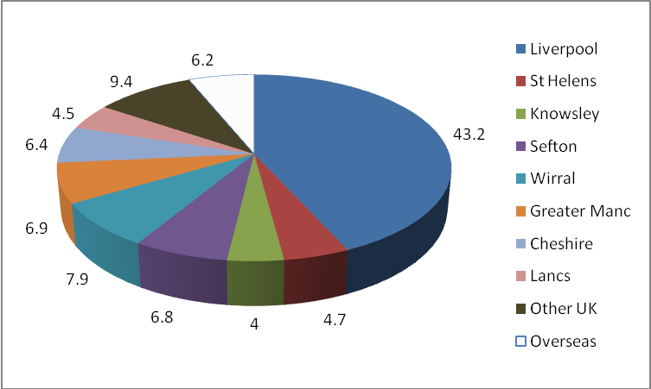
Percentages, base=323

2.2 group composition
 | Respondents were asked whether they had attended the event alone or as part of an organised group. The largest proportion, two fifths (39.6%) were respondents who came with family – with a further quarter (26.0) with partner/spouse.
figure 5 | personal group characteristics
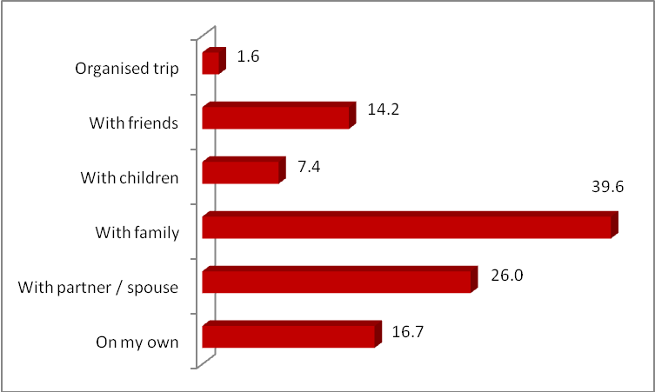
Percentages, base=312
 | Linked to the above data, figure 6 records the size of groups at the event.
figure 6 | personal group size
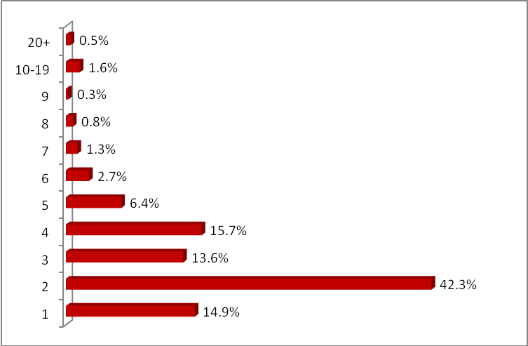
Percentages, base=202

 | The average group size was 3.3. Group size by type of party is detailed in table 3.
table 3 | mean group size
On my own | 1.0
With partner / spouse | 2.1
With family | 4.0
With children | 3.3
With friends | 4.2
Organised trip | 23.3
Our question on the gender and age make-up of respondent’s whole visiting party gives us a broader picture of the age and gender of those present on the day. Figure 7 shows high levels of representation of children (16.5 per cent were aged 10 and under – with more girls than boys!) and something of a bulge in the main parental age group of 35-44 (14.0 per cent). However the main theme is the spread of representation across all ages from young children, teens, “pre-parents” through to older age groups – with 24.2 per cent aged 65 and over.

The data in figure 7 also identifies a slight female majority i.e. 52.4% compared to 47.6% male.

figure 7 | group demographic profile
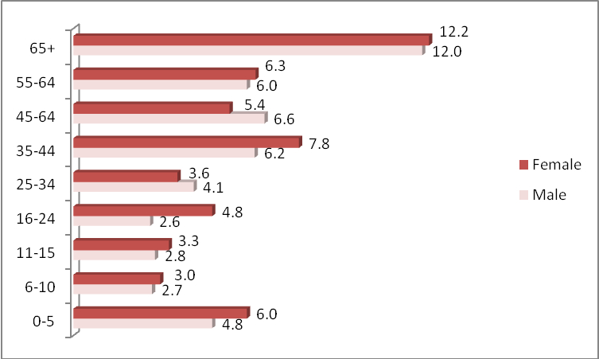
Percentages, base=1267 Note: Varying breadth of age bands illustrated

section 3 | findings (2) residents, staying visitors & day visitors
3.1 type of visitor
Just over four in ten (43.2%) of respondents and individuals approached were residents of Liverpool city. A further 44.1 per cent were visiting the event as part of a day trip from outside the local area, including Sefton/Wirral/Knowsley/St Helens. Around one in eight (12.7%) stated they were on a staying trip, and making a visit to the event as part of that trip.

Of respondents staying: 10 groups were from the South-east; 5 from the north-west; 3 from Yorkshire and the North East; 3 from the South- west; 3 from the East Midlands. There were also 6 staying groups from Europe and 2 from outside Europe.

figure 8 | type of visitor
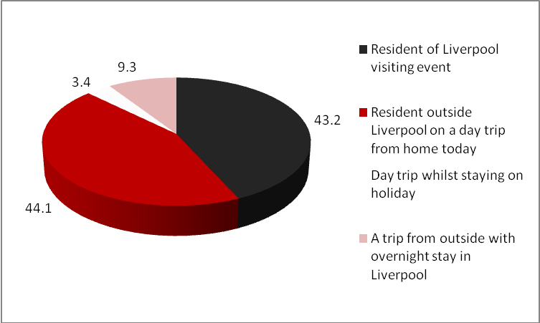
Percentages, base=379
3.2 accommodation details
3.2.1 length of stay |  | On average, those staying overnight in Liverpool in all types of accommodation were staying 3.9 nights. This is based on only 57 respondents staying away from home in Liverpool and hence has a much lower level of associated reliability.

3.2.2 accommodation type | 44 respondents stated that they had used commercial accommodation, as shown in Table 4 below. A further 4 respondents had stayed on a boat and did not spend on accommodation in Liverpool – plus one in a touring caravan. The remaining 10 respondents were staying with friends and relatives.
table 4 | type of accommodation used
Hotel | 39
Pub | 0
B&B/Unreg hotel | 3
Campus accomm. | 0
Hostel | 2
3.2.3 accommodation location | 50 respondents were staying in Liverpool with 3 respondents elsewhere on Merseyside and 2 staying further afield (in the North-west).
3.2.4 accommodation expenditure | On average respondents staying in all types of accommodation spent £40.74 per person per night on accommodation. It should be noted that this is based on only 44 respondents.

section 4 | findings (3) visitor behaviour
  - method of travel
 | Over six in ten (61.0%) arrived by public transport - with 45.3% by train and a further 11.2% by bus (or scheduled coach) and 4.5% by ferry. Most of the remaining visitors travelled to Liverpool by car (32.6%).
figure 9 | mode of transport
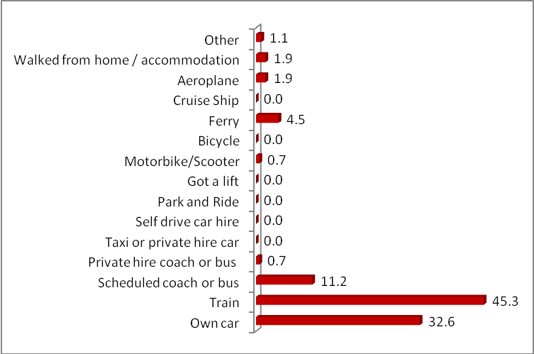
Percentages, base=377

4.2 main reason for visiting Liverpool
 |  | Over four fifths (81.4%) of visitors to Liverpool were there predominantly to attend the Sea Odyssey. Just under one in ten (8.3%) were there to visit Liverpool in general and a slightly smaller proportion (6.4%) to visit friends or relatives.

figure 10 | main reason for visiting Liverpool
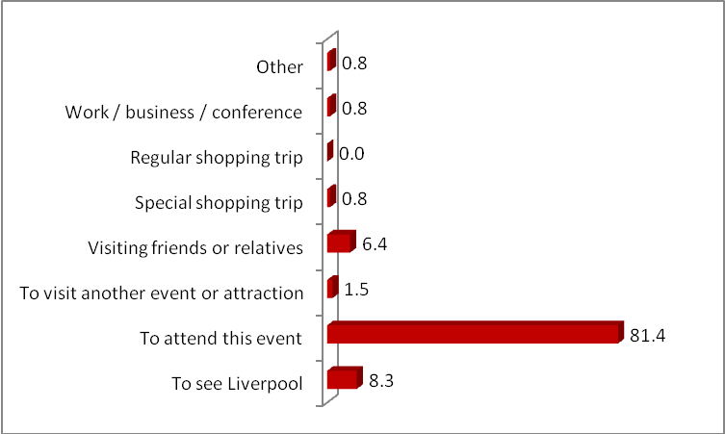
Percentages, base=381
Of the respondents to the question on how important Sea Odyssey was to their decision to be in Liverpool, over two-thirds (67.7 per cent) stated that the even was the sole reason with a further 12.2 per cent stating it was a very important reason. Thus eight out of ten of the estimated 800,000 visitors had been attracted mainly by the event.

A significant minority (11.9%) stated that it was of no importance – i.e. the individual(s) would have been in Liverpool irrespective.

figure 11 | importance of event in decision to visit Liverpool
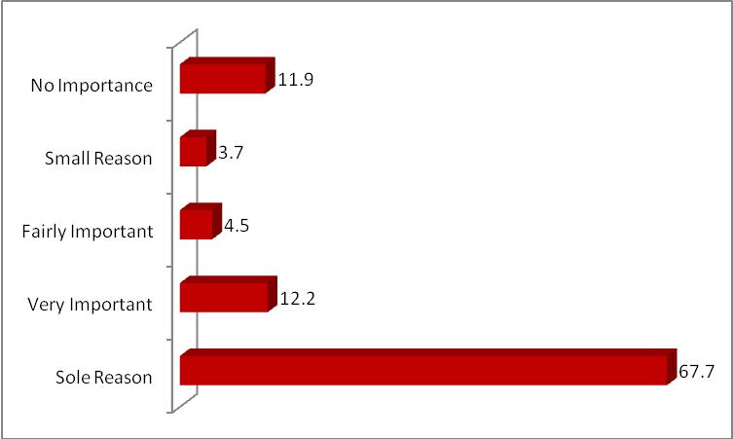
Percentages, base=381
 | Most of the attendees were at least reasonably regular visitors to the city. Figure 12 shows that amongst non-residents of the city 35.1 per cent visit at least monthly and all but 15.5 per cent at least annually.

figure 12 | frequency of visiting Liverpool
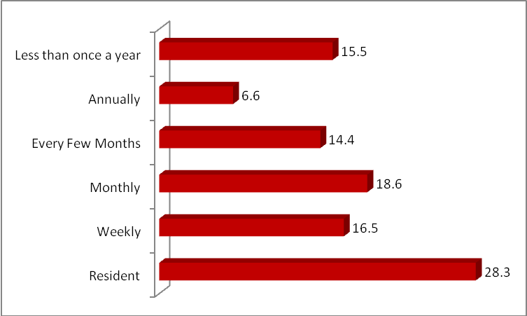
Percentages, base=381
4.3 reasons for visiting event
Two-thirds (63.8%) of respondent’s stated that they had visited Sea Odyssey because they wanted a day out.

Almost a fifth (19.3%) came because they had seen or heard advertising, whilst other significant factors included friends/family and/or children wanting to go:

figure 13 | reasons for visiting event
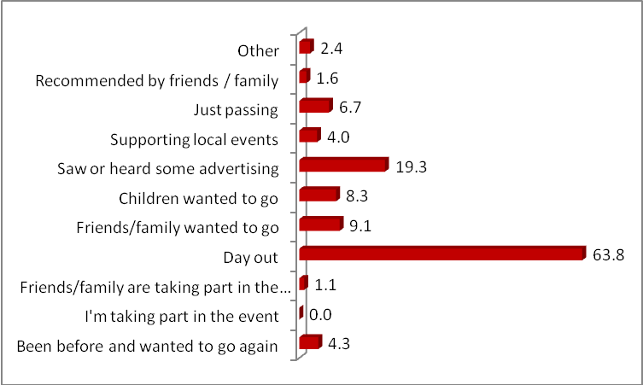
Percentages, base=381; note percentages exceed 100 due to multiple responses

The decision to visit the event was made for almost three-quarters (74.4%) in the 7 days before the event, with one third (33.8%) making the decision on the day they attended the event.

A reasonable minority (14.7%) planned their visit to the event a considerable time in advance (2 months or longer).

figure 14 | advance planning of visit
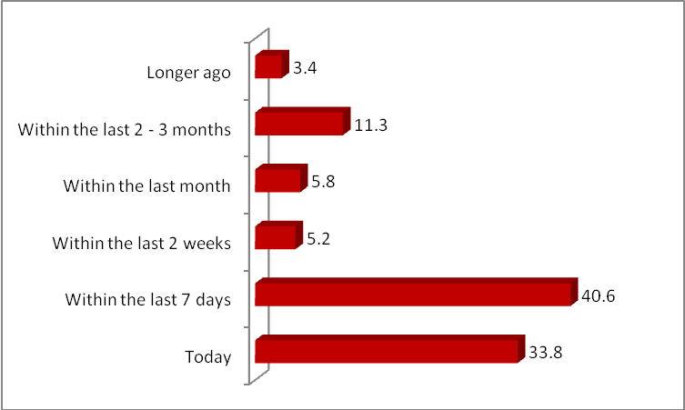
Percentages, base=295

section 5 | findings (4) marketing & promotion
  - effectiveness of marketing activity
In an attempt to gain a measure of marketing channels used to promote the event, respondents were asked to detail how they found out about the event and what the main influence was on their decision to visit the event, as shown below.

Almost one half found out about the event through TV (49.2%) and a quarter via newspapers (26.6%). These two sources also had the biggest influence on people’s decision to visit the event – accounting for 24.7% and 16.9% of attendees respectively.

Other media cited as being the main influence by significant proportions were:
- Word of mouth (16.0%);
- Radio (10.5%).
- Leaflet/flyer for the event (8.7%);
- Website (7.8%);

figure 16 | information sources and influences on visit
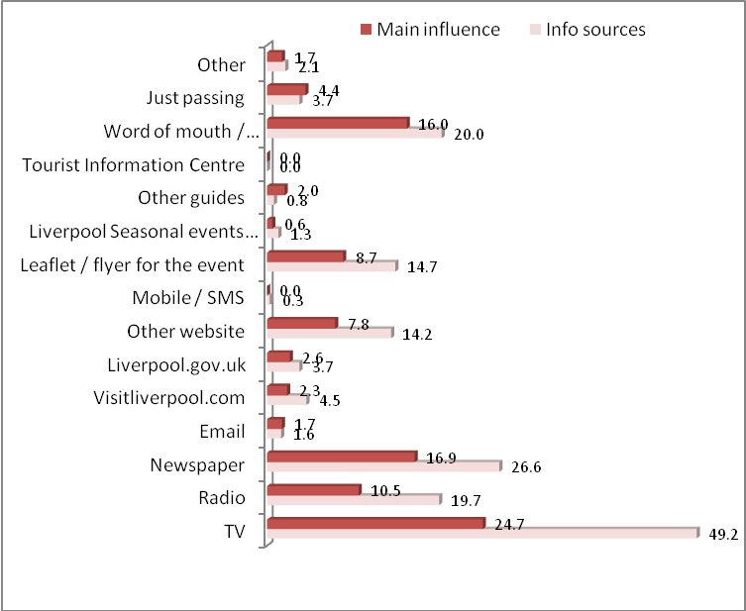
Percentages, base=312, percentages do not total 100 as respondents could select more than one answer

section 6 | findings (5) visitor satisfaction
6.1 satisfaction with event
Visitors were asked to rate their levels of satisfaction with various aspects of the event using the Likert scale (where 1=very poor and 5=very good), as shown in figure 18. Responses in many areas were extremely positive.

Overall impression of Liverpool received the highest satisfaction rating – with almost all (97.9%) stating it was very/fairly good.

Overall enjoyment received the second highest satisfaction rating (93.6% very/fairly good) followed by event quality (93.6% very/fairly good). In fact no respondents rated overall enjoyment as either very or fairly poor.

Lower scores were awarded for event signposting and for parking and other facilities – although only signposting received negative ratings from more than one in ten.

figure 18 |  | satisfaction with event criteria
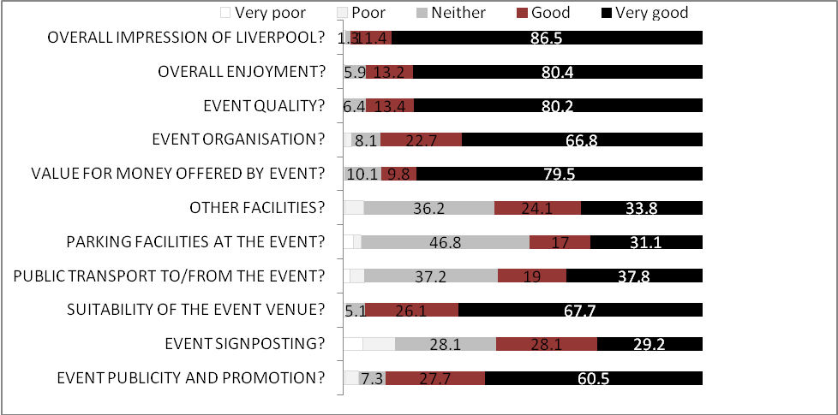
Percentages, bases=299- 307
 |  | On this five-point scale, a mean rating of above 3.0 indicates a net satisfaction level, whilst any rating below 3.0 indicates a net level of dissatisfaction. Table 5 overleaf shows the mean scores awarded by respondents. The overall mean enjoyment score was an impressive 4.7 – whilst more moderate scores were given to signposting and parking facilities.

table 5 |  | mean satisfaction scores
Publicity & promotion |  | 4.4
Event signposting |  | 3.7
Suitability of venue |  | 4.6
Public transport |  | 3.9
Parking facilities |  | 3.7
Other facilities |  | 3.9
Event organisation |  | 4.7
Event quality |  | 4.5
Overall enjoyment |  | 4.7
A good measure of customer satisfaction is to assess whether visitors would recommend the event to friends and family. Over four fifths (84.6%) of respondents said they were very likely to recommend the event. A further one in ten (9.2%) said that they were quite likely.

A tiny proportion i.e. 0.5 per cent gave a negative response (very/quite unlikely), as shown in figure 19:

figure 19 |  | likelihood to recommend to friends/family
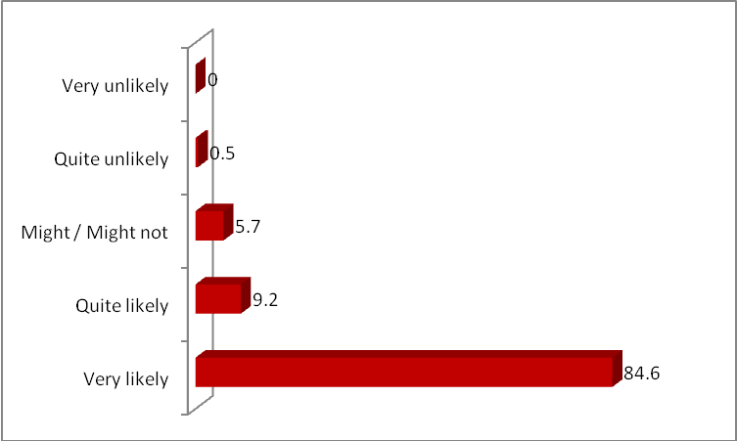
Percentages, bases=309
 |  | Respondents were also asked how likely they were to visit Sea Odyssey again if it was held in the future. Figure 20 shows that almost nine in ten (88.9%) were very likely to visit it again. Only a very small minority (1.3%) were very/quite unlikely to visit again.
figure 20 |  | likelihood of visiting again
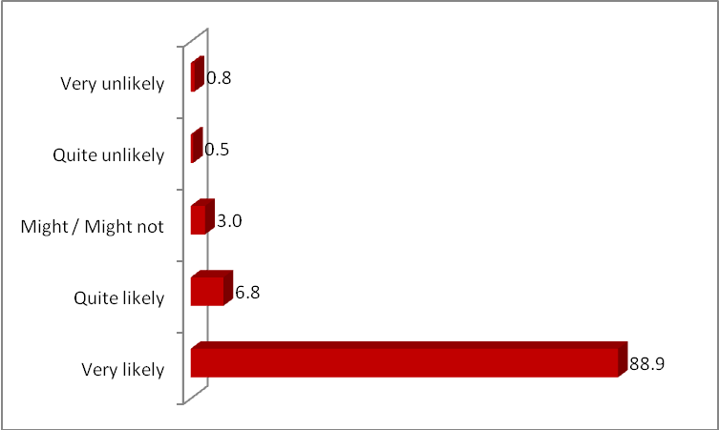
Percentages, bases=310
Respondents were also asked if they had any suggestions for improvement and development of the event, with the majority of respondents stating that it could not be improved (97 mentions). Other positive mentions included
- Great for the city (15 mentions);
- Bring it back in future (12 mentions);
- Excellent/very good (25 mentions).

Specific criticisms were limited to one or two responses –with a niche of complaints on Sunday relating to the earlier than scheduled finish (9 mentions). Other comments included

- Visibility – couldn’t see (8 mentions)
- Timekeeping in general (8)
- Traffic problems (7)
- More facilities – drinks kiosks (4).

It is worth noting that field staff received several complaints on the final Sunday when the event finished before the scheduled timing.

6.3 satisfaction with Liverpool
 |  | Visitors were also asked to rate their overall impression of Liverpool using the Likert scale (where 1=very poor and 5=very good), as shown in figure 21 below. Indeed the chart shows the almost uniform positive ratings for the city – with tiny minorities (less than 1 per cent overall) stating a poor impression.
figure 21 |  | overall impression of Liverpool
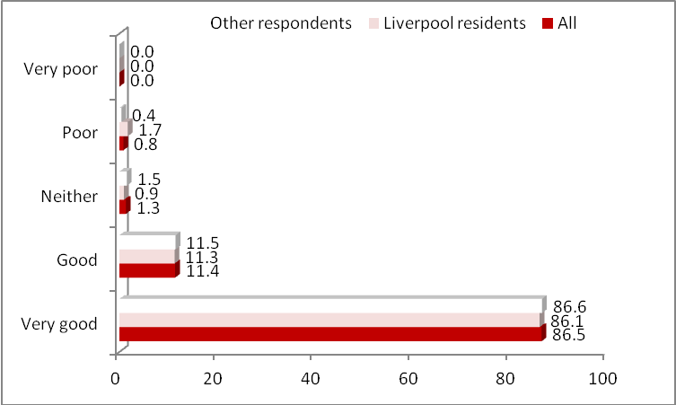
Percentages, non-residents base=163, residents base=148, all visitors base=311
 | The mean score awarded by respondents was 4.8 out of 5 across all types of visitor.

section 7 | findings (6) economic impact
7.1 average visitor spend
Visitors were asked to estimate how much they and their party were likely to spend during the whole period of their stay at the Sea Odyssey Festival. Given that visitors were being asked to recollect their expenditures and to forecast future spending the following figures should be treated as estimates. Studies using the diary method of keeping account of spending have shown that visitors’ own estimates, as used in the Sea Odyssey Festival, are usually on the conservative side.

The following results are based on the expenditure of visitors to the Sea Odyssey Festival in April 2012.

384 groups of people were interviewed during 2 days of the Festival totalling 1267 individuals. Of the 384 interviews, 10 respondents were in groups of 10 or more and did not give expenditure for the whole group. Therefore, these groups and their associated spend have not been included.

figure 22 | average spend – all visitors (£)
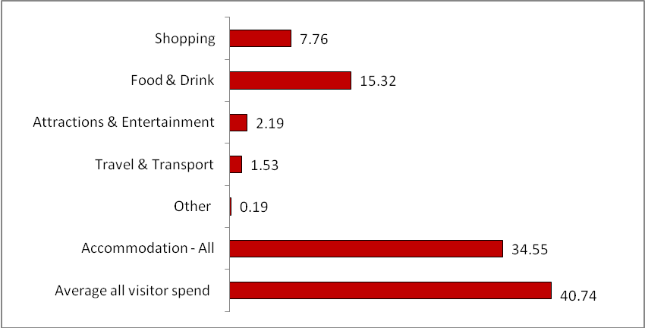
All bases=384, Accommodation base=44
The average spend by all visitors to the Festival was approximately £40.74 per person per night. Visitors staying overnight in the city spent on average £34.55 per person per night on accommodation.

If you exclude the expenditure on accommodation, the highest level of spend per person was for food and drink (£15.32), followed by shopping (£7.76). Attractions and entertainment accounted for (£2.19) of overall spend, followed by travel and transport (£1.53) and “other” (£0.19) which accounted for a much lower level of spend.

7.2 spend of visitors in Liverpool – main reason attending
the Sea Odyssey Festival
When excluding residents, 81.4% of visitors’ main reason for visiting Liverpool was for the Sea Odyssey Festival. When looking at the data by reason for visit, figure 23 shows that the total average spend associated with those whose main reason for visiting the area was for the Festival, is much lower with an average spend of £24.14 per person per day.

Food and drink saw the highest level of spend accounting for £11.87 of visitor expenditure per person.

figure 23 | average spend – all visitors –Sea Odyssey Festival associated trips (£)
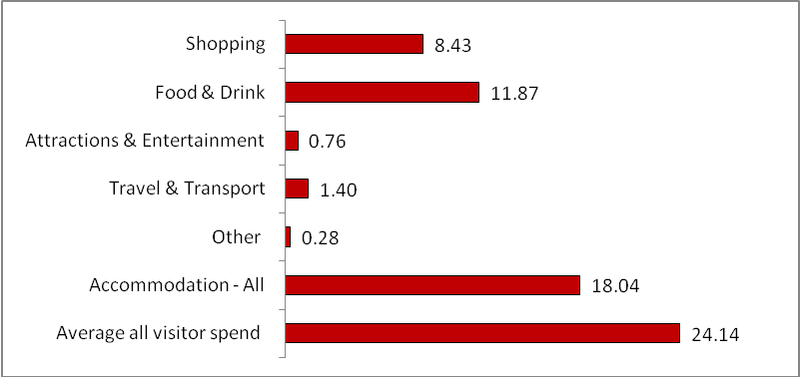

7.3 summary of economic impact
- The total visitor spend generated by the Festival is estimated as £31,028,167, of which £10,375,500 was on accommodation, and £20,652,667 on all other items. These estimates include all expenditure on accommodation for staying visitors over the duration of their visit.
- The survey responses indicated that 99 per cent of this amount was spent in Liverpool itself, with 1% in the rest of the North West.
- It is estimated that 69.3% of the expenditure was additional expenditure related to the event – generating £21,359,397 for the city and £143,123 elsewhere in the North West.
- Total expenditure generated by the event, including multiplier effects, was £46,548,805, of which 69.3%, or £32,258,322 was additional.
- The event spend is estimated to have supported 949.2 jobs – 633.8 directly and 315.4 indirectly – on the basis of an average turnover required per job of £50,000 in the accommodation, catering and retail sectors, and £35,650 in the attractions sector. It should be noted that these are job years since they only occur in the year that the festival takes place. Conventionally, full time permanent jobs are taken as 10 job years.

7.4 gross visitor spend
In calculating the gross visitor spend, a number of factors need to be taken into account. Firstly, there is the coarse total visitor spend, which is calculated by multiplying the mean spend per person per day with the estimated number of visitors to the event. Typically, to take into account the accommodation spend, this figure is divided between staying and non-staying visitors (as displayed in the table below).

The estimated total gross visitor spend for Sea Odyssey Festival is £31,028,167. This is based on allocating all of the staying visitors’ expenditure on accommodation to the event. The estimated geographic allocation of this expenditure, based on survey returns, is shown in table 6 below.

table 6 | allocation of visitor expenditure – Sea Oydessy Festival
 | Expenditure |  | Of which: spent in
 | £ | % | Liverpool | Merseyside | Elsewhere in NW
Accommodation | £10,375,500 | 33.44% | £10,375,500 | £0.00 | £0.00
Shopping | £5,952,000 | 19.18% | £5,892,480 | £35,117 | £24,403
Food & drink | £11,706,500 | 37.73% | £11,589,435 | £69,068 | £47,997
Attractions | £1,685,417 | 5.43% | £1,668,563 | £9,944 | £6,910
Travel | £1,167,083 | 3.76% | £1,155,412 | £6,886 | £4,785
Other | £141,667 | 0.46% | £140,250 | £836 | £581
Total | £31,028,167 | 100.00% | £30,821,640 | £121851 | £84,676
% of total | 100.0% |  | 99.3% | 0.4% | 0.3%
 | The figures indicate that 33.44% of total expenditure was on accommodation. The single largest item of expenditure was food and drink, which comprised 37.73% of total expenditure.

7.5 step 2: multiplied expenditure
 | The sum of £31,028,167 represents the immediate impact of visitor expenditure on the economy. Some of this expenditure was recycled within the City economy, in additional expenditure on bought-in services and supplies. We have used the estimates of local linkages derived from previous economic research in Liverpool to arrive at estimates for the amount of multiplied expenditure generated by the Sea Odyssey Festival, as set out in table 7.
table 7 | multiplier effects of the expenditure of visitors to the Sea Odyessy Festival
 | Round 1 Expenditure | Of which: |  |  |  | % multiplier |  |  |  | Multiplied Expenditure
 | £ | Staying visitors |  | Day visitors |  | (to nearest %) |  |  |  | £
Accommodation | £10,375,500 | £10,375,500 |  | £0 |  | 75% |  |  |  | £7,781,625
Shopping | £5,952,000 | £597,000 |  | £5,355,000 |  | 19% |  |  |  | £1,130,880
Food & drink | £11,706,500 | £5,374,000 |  | £6,332,500 |  | 50% |  |  |  | £5,853,250
Attractions | £1,685,417 | £375,000 |  | £1,310,417 |  | 37% |  |  |  | £623,604
Travel | £1,167,083 | £345,417 |  | £821,667 |  | 7% |  |  |  | £81,696
Other | £141,667 | £0 |  | £14,667 |  | 35% |  |  |  | £49,583
Total | £31,028,167 | £17,066,917 |  | £13,961,250 |  |  |  |  |  | £15,520,638
 | 100.0% | 55% |  | 45%
 | The total economic impact including the multiplier is shown in table 8 below.
table 8 | total economic impact including the multiplier
 | Round 1 Expenditure |  | Multiplied Expenditure |  |  |  | Total
Accommodation | £10,375,500 |  | £7,781,625 |  |  |  | £18,157,125
Shopping | £5,952,000 |  | £1,130,880 |  |  |  | £7,082,880
Food & drink | £11,706,500 |  | £5,853,250 |  |  |  | £17,559,750
Attractions | £1,685,417 |  | £623,604 |  |  |  | £2,309,021
Travel | £1,167,083 |  | £81,696 |  |  |  | £1,248,779
Other | £141,667 |  | £49,583 |  |  |  | £191,250
Total | £31,028,167 |  | £15,520,638 |  |  |  | £46,548,805
 | The geographic allocation of this expenditure is shown in table 9.
table 9 | geographic allocation of Round 1 and multiplied expenditure
 | Total | Of which:
 | £ | Liverpool |  |  | Merseyside |  |  |  | Elsewhere in NW
Accommodation | £18,157,125 | £18,157,125 |  |  | £0 |  |  |  | £0
Shopping | £7,082,880 | £7,012,051 |  |  | £41,789 |  |  |  | £29,040
Food & drink | £17,559,750 | £17,384,153 |  |  | £103,603 |  |  |  | £71,995
Attractions | £2,309,021 | £2,285,931 |  |  | £13,263 |  |  |  | £9,467
Travel | £1,248,779 | £1,236,291 |  |  | £7,368 |  |  |  | £5,120
Other | £191,250 | £189,338 |  |  | £1,129 |  |  |  | £784
Total | £46,548,805 | £46,264,889 |  |  | £167,511 |  |  |  | £116,406
To estimate the employment effects of this expenditure, we applied estimates of turnover required per job derived from earlier economic research in Liverpool to calculate the number of jobs – full-time employee (FTE) equivalent – supported by the Sea Odyssey Festival. The turnover per job estimates by sector are as follows:

- Accommodation: £50,000;
- Shopping: £50,000;
- Food & drink: £50,000;
- Attractions: £35,650;
- Travel: £50,650.

Based on these estimates, the employment effects of the Sea Odyssey Festival expenditure are as shown in table 10a below.

table 10a | employment effects of Round 1 and multiplied expenditure
 | Round 1 Expenditure |  | Multiplied Expenditure |  |  |  | Total
Accommodation | 207.5 |  | 155.6 |  |  |  | 363.1
Shopping | 119.0 |  | 22.6 |  |  |  | 141.6
Food & drink | 234.1 |  | 117.1 |  |  |  | 351.2
Attractions | 47.3 |  | 17.5 |  |  |  | 64.8
Travel | 23.0 |  | 1.6 |  |  |  | 24.6
Other | 2.8 |  | 1.0 |  |  |  | 3.8
Total | 633.8 |  | 315.4 |  |  |  | 949.2
 | The geographical allocation of these jobs is shown in table 10b.
table 10b | geographical location of jobs supported by Round 1 and multiplied expenditure
 | Round 1 Expenditure |  | Multiplied Expenditure |  |  |  |  | Total
Liverpool | 629.6 |  | 313.8 |  |  |  |  | 943.4
Merseyside | 2.4 |  | 1.0 |  |  |  |  | 3.4
Elsewhere in the North West | 1.8 |  | 0.6 |  |  |  |  | 2.4
Outside the North West | 0.0 |  | 0.0 |  |  |  |  | 0.0
Total | 633.8 |  | 315.4 |  |  |  |  | 949.2

7.6 step 3: additional expenditure related to the event
The next issue to be addressed is how much of the expenditure was new or additional, as opposed to having been displaced from expenditure which would have occurred anyway. In total, 67.4% of respondents stated that they would otherwise have stayed home or gone to work, while 1.9% stated that they would otherwise have gone somewhere outside the North West. The remaining 30.7% of respondents stated that they would have done something else in Liverpool, Merseyside or the North West or did not specify what they would have done.

Based on these survey responses, we can estimate that 69.3% of total expenditure – or approximately £21,502,520 of Round 1 expenditure and £10,755,802 of multiplied expenditure – was additional spend related to the event by people who would not otherwise have been spending on the day of the event, while 30.7% of total expenditure would have been spent doing “something else” in Liverpool or the North West, and so would have occurred anyway within the city and region, and was displaced from other activities. In summary, additional expenditure related to the Sea Odysessy Festival is as set out in the table 11 below.

table 11 | additional expenditure related to the Sea Odyssey Festival
 | £
Gross visitor spend | £31,028,167
Multiplied expenditure | £15,520,638
Total expenditure generated by the Sea Odyssey Festival | £46,548,805
Additional visitor expenditure related to the event | £21,502,520
Additional multiplied expenditure | £10,755,802
 | £32,258,322
Geographic allocation:
Liverpool | £32,061,568
Merseyside | £115,339
Elsewhere in NorthWest | £81,415
Outside the North West | £0.00
 | £32,258,322
 | The allocation of additional visitor expenditure related to the event by sector, and the total jobs supported by this expenditure by sector, is shown in table 12a overleaf.

table 12a | additional jobs related to the Sea Odyssey Festival
 | Additional Expenditure |  |  | Additional Jobs
Accommodation | £12,582,888 |  |  | 251.7
Shopping | £4,908,436 |  |  | 98.2
Food & drink | £12,168,907 |  |  | 243.4
Attractions | £1,600,151 |  |  | 44.9
Travel | £865,404 |  |  | 17.1
Other | £132,536 |  |  | 2.7
Total | £32,258,322 |  |  | 657.8
 | The geographic location of the additional expenditure and jobs related to the Sea Odyssey Festival is shown in table 12 b below.
table 12b | geographic location of additional expenditure and jobs related to the Sea Odyssey Festival
 | Additional Expenditure |  |  | Additional Jobs
Liverpool | £32,061,568 |  |  | 683.8
Merseyside | £0.00 |  |  | 0.0
Elsewhere in the North West | £196,754 |  |  | 4.0
Outside the North West | £0.00 |  |  | 0.0
Total | £32,258,322 |  |  | 657.8
7.7 total economic impact
 | Table 13 summarises the total economic impact of the Sea Odyssey Festival at the three levels.
table 13 | total economic impact of the Sea Odyssey Festival
 | Total | Liverpool | Mersey-  side |  | North West
1. Gross visitor spend | £31,028,167 | £30,821,640 | £121,851 |  | £84,676
2. Multiplied expenditure | £15,520,638 | £15,365,432 | £91,572 |  | 63,634
Sub-total: | £46,548,805 | £46,187,072 | £213,422 |  | £148,311
Total jobs | 949.2 | 939.7 | 56.0 |  | 38.9
3. Additional expenditure | £32,258,322 | £32,061,568 | £115,339 |  | £81,415
Additional jobs | 657.8 | 653.8 | 2.4 |  | 1.6
As shown in table 13:

- the total Round 1 economic impact of the event was £31,028,167 of which £30,821,640 was generated for Liverpool and £206,527 for the rest of the North West/Merseyside.
- Round 2 or multiplied economic impact of the event was £15,520,638;
- In total, Round 1 and multiplied expenditure amounted to £46,548,805 of which £32,258,322 represented additional expenditure generated by the event (69.3%), while £14,290,483 (30.7%) would have been spent in Liverpool whether or not the event had taken place. Of the additional expenditure, the total amount of £32,061,568 was spent in Liverpool itself and £196,754 was spent in the rest of the North West/Merseyside.
- based on the Cambridge Econometrics’ estimates of average turnover per full-time equivalent (FTE) job in each sector, the expenditure generated by the Sea Odyssey Festival was sufficient to support 949.2 jobs – 939.7 directly and 94.9 indirectly – of which 657.8 FTE jobs were additional, with 653.8 located within Liverpool and 4.0 elsewhere in the North West/Merseyside.

section 8 | findings (7) North Liverpool
7.1 rating of area
The 68 visitors to Stanley Park and Everton Brow were asked to rate the area in terms of

- A place which will develop in future;
- A place people want to visit
- A sense of community.

figure 24 | attitudes towards North Liverpool (Stanley Park/Everton Brow visitors)
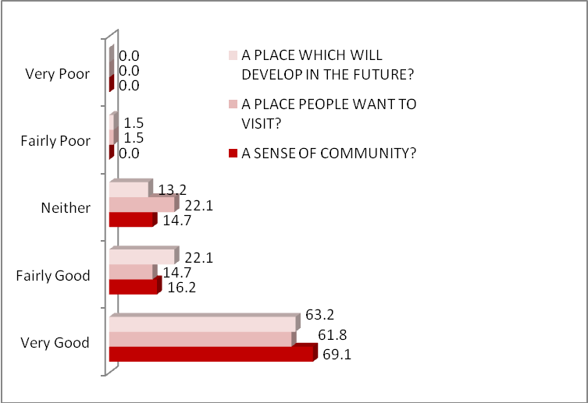
Base=68
 | Thus the responses were generally very positive – with in all cases more than 6 in 10 rating their area as very good – and in terms of a sense of community close to seven out of ten.
7.2 promoting the area
The 68 visitors to Stanley Park and Everton Brow were also asked

- Whether the City council should host more of the city’s programme of community events and festivals in Stanley Park;
- How much potential there is to develop this area as a centre for football-based tourism.

In terms of the former there was (not surprisingly) strong support – with 94.1 per cent agreement. In terms of the latter figure 65 shows considerable support for the proposition:

figure 22 | Views on potential for football based tourism
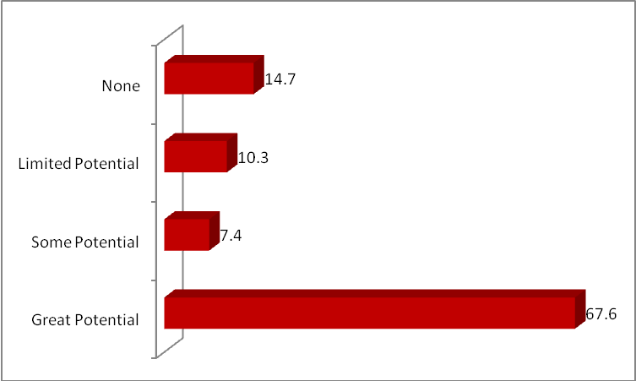
Base=68
When those who responded positively to the above question were asked how it might be possible to make the area attract more football tourism, the main responses were as follows:

- Better/improved/cheaper parking (8)
- Places to eat/drink (5)
- Bigger/new stadium (5)
- More events in area (3)
- Greater promotion of the district (3)
- Better teams! (2).

The 17 respondents who responded negatively (in Figure 25) were asked why. The main response related to their personal lack of interest or dislike of football (9 responses) with the other key responses as follows:

- Not needed/attracts fans anyway (3)
- No space/room for more fans (3).

APPENDIX 1 | questionnaire

For a more accurate demography of visitors at the event rather than respondents, see section 2.2
This figure is distorted somewhat by one overseas visitor staying for 30 nights

